**Classification Assignment**

Problem Statement or Requirement:

A requirement from the Hospital, Management asked us to create a predictive

model which will predict the Chronic Kidney Disease (CKD) based on the

several parameters. The Client has provided the dataset of the same.

1. Identify your problem statement:

Predict the Chronic Kidney Disease based on the given dataset using Machine Leaning -> Supervised Learning -> Classification

1. Tell basic info about the dataset (Total number of rows, columns)

399 rows and 28 columns.

1. Mention the pre-processing method if you’re doing any (like converting

string to number – nominal data)

Nominal data: converting rbc, pc, pcc, ba, btn, dm, cad, appet, pe, ane and classification strings to number.

1. Develop a good model with good evaluation metric. You can use any

machine learning algorithm, you can create many models. Finally, you

have to come up with final model.

5.) All the research values of each algorithm should be documented. (You

can make tabulation or screenshot of the results.)

1. Logistic-Grid-Classification

1. SVM-Grid-Classification

1. Decision Tree-Grid-Classification

1. Random Forest-Grid-Classification

1. KNN-Classification

1. Naïve baye’s-Classification

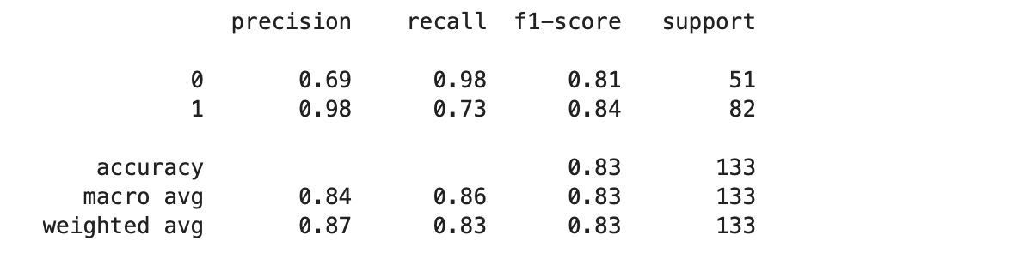

1. Mention your final model, justify why u have chosen the same.

Final model is Random Forest Grid Classification because of the Accuracy is 0.99.